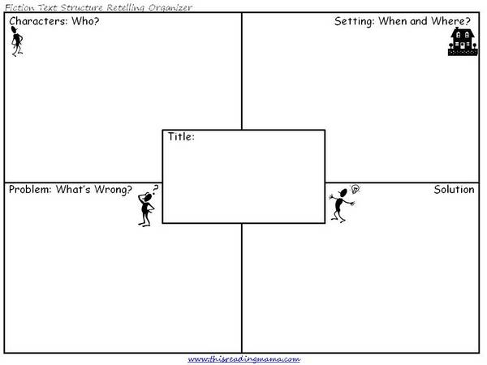

Worldview | Culture
Indigenous | Reslience

