**OLJH**

**Summer Reading**

**2016**

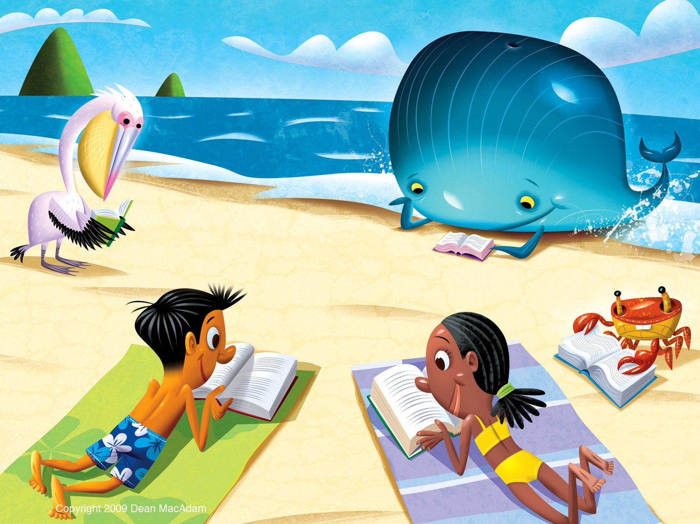

**The summer reading requirement for the 2016-2017 school year gives our students a multitude of high interest novels from which to choose along with utilizing their creative flair for demonstrating the fulfillment of this assignment. Students will choose and read one of the novels from the 2016-2017 SSYRA list. This list of novels is geared to appeal to a variety of young adolescent readers.**

**Students have a variety of ways to access the book they choose to read. The local book stores have copies available for sale or you may purchase the book online. Students may also borrow books from the public library. However you choose to get yours, get it soon and begin your assignment. Once you have completed reading your book, you are ready to move on to the book review. This is the part of the assignment that allows your creative juices to flow.**

**First, let’s answer the question: what exactly is a book review?**

**A book review communicates a sneak peek at a book analyzing its content (*tell us about the book without telling the ending*), theme (*describe the main idea or message of the story*), style (*describe the author’s style of writing and tell whether it is one that all readers may enjoy*), and merit (*did you enjoy the book, is it worth reading, etc.*). It may even tell how a reader may obtain a copy of the book.**

**Now, let’s look at what OLJH requires in their summer reading book review:**

## OLJH Summer Reading Book Review

**You should choose one of the OLJH Summer Reading selections and complete a book review. The book review may be in any of the following formats:**

* **A digital presentation such as PowerPoint, PowToon, Prezi, Keynote, or Prezentit.**
* **A video presentation such as a movie of you reviewing the book or a book trailer.**
* **A visual representation using pictures and words on a poster board, artist canvas, or construction paper no larger than 11x14 to construct the review. You may use any artistic medium you choose: acrylic, oils, mosaic, paper, pencil, watercolors, etc.**
* **Using written paragraph format- Approximately 5 paragraphs, typed or handwritten.**

**Regardless of the format chosen for the book review, students must incorporate the following five elements:**

**INTRODUCTION**

1. **Author/Title**

* **Name the author and the title.**

**SUMMARY**

1. **Genre**

* **What genre of literature was it?**
* **How did it compare to another work in this genre?**

1. **Setting**

* **Note the time period and location of the story.**
* **How did the setting drive or influence the plot of the book?**

1. **Plot**

* **Give a brief plot summary without giving away key details.**

**EVALUATION**

1. **Your Opinion**

* **This is the most important part of the review.**
* **Did you like or dislike the story? Explain your answer using supporting evidence from the story.**
* **Would you read more books by this author? Why or why not?**
* **Would you encourage others to read this book? While explaining your answer pull your favorite or least favorite part from the book to support your answer.**

**\*\*Projects should be turned in to the student’s English/Language Arts teacher by September 9, 2016. \*\***

**Please contact Ms. Walker-Ford (**[**alwalker-ford@oneclay.net**](mailto:alwalker-ford@oneclay.net)**) if you have any questions.**

**Sunshine State Young Readers Award Books**

**2016-2017 List for Grades 6-8**

***All Fall Down* by Ally Carter**

Grace Blakely’s life was turned upside down the night her mother was murdered. Grace believes the scarred man who killed her mother is lurking somewhere on Embassy Row, her new home in the country of Adria. She and her new friends set out to find him and stop another murder from happening. But will it cost her everything? Will Grace find somebody to listen to her before it’s too late?



***Bot Wars* by J.V. Kade**

Aiden (Trout) misses his dad whose been missing since the end of the Bot Wars. That conflict, between the increasingly advanced robots who were demanding rights and the humans who owned them, has left the United Districts in dire straits. His older brother won’t answer his questions, so he decides to post a video asking for information. It goes viral and now his brother is missing and Trout’s a wanted fugitive. Nothing makes sense anymore and Trout doesn’t know who to trust.

***The Crossover* by Kwame Alexander**

Using riffs from concrete poetry, hip-hop and jazz, this is the verse story of twins Josh and Jordan Bell. Both boys dominate the basketball court, and Josh is also a master of rhythm and rhyme. Their family bond is strong. Things change when Jordan meets a new girl and dad refuses to confront his health problems. Josh finds himself left in a game he no longer feels comfortable playing without his teammate and coach by his side.

***Echo* by Pam Munoz Ryan**

The novel, introduced with the fairytale-like story of Otto and the prophecy of a harmonica, transitions to the lives of Friedrich in WWII Germany, Mike, an orphan in 1935 Great Depression Pennsylvania, and Ivy on the WWII homefront in 1942 California all impacted by the history of their times, a harmonica, and the power of music.



***Frenzy* by Robert Lettrick**

Frenzy is a fast paced thrilling story with an apocalyptic feel. Heath and his friends are left to defend themselves and survive a ravenous disease that has taken over the surrounding wild animals that live in the forest of Camp Harmony. The summer camp residents are forced to turn to one other and remain alive through the FRENZY!



***The Honest Truth* by Dan Gemeinhart**

Mark leaves home with only two things: a duffel bag and his dog, Beau. He is determined to fulfill his lifelong dream of climbing Mount Ranier. But, Mark is sick, and he’s sick and tired of the treatments he has to receive for his illness. The story of Mark’s journey is told alternately from Mark’s point of view, and that of his best friend, Jessie, who’s been sworn to secrecy about Mark’s whereabouts.



***Insignia* by S.J. Kincaid**

When fourteen year old Tom first enters an elite military division during the middle of WWIII, his biggest achievement is his prowess at virtual reality games, his killer instinct in gambling and a spelling bee he lied about winning. But this may just be the perfect combination to win the war…if he agrees to submit to the unique and top secret conditions of becoming a space-age warrior. Tom has always wanted to be someone important. But at what cost?

***Nickel Bay Nick* by Dean Pitchford**

The town of Nickel Bay has given up hope. Nickel Bay Nick a local good Samaritan who hides hundred-dollar bills around town each Christmas season has abandoned them. Sam Brattle is feeling the abandonment more than others. His dad’s bakery is on the brink of bankruptcy, his mother has a new family and he has fallen in with the wrong crowd. But then, one night changes Sam’s life forever...



***The Neptune Project* by Polly Holyoke**

In this dystopian adventure, the government is forcing citizens to leave the coasts to move inland to work in labor camps. Nere, who has always loved the water, and can communicate with dolphins, finds out that she and others have been genetically mutated to be able to breathe underwater. With danger following at every turn, will the Neptune Children escape the government’s clutches and begin a new human colony in the ocean as they were designed to do?

***The Sinister Sweetness of Splendid Academy* by Nikki Loftin**

Splendid Academy, a new school in Lorelei’s neighborhood, almost seems too good to be true. With a fantastic playground, gourmet food, and optional homework, this school seems like every kid’s dream! That is, until Lorelei discovers that the school is hiding a sinister secret in this Hansel and Gretel twist.



***The Summer I Saved the World in 65 Days* by Michele Weber Hurwitz**

Thirteen-year-old Nina begins her summer vacation by doing a random act of kindness for a neighbor. When she sees how well received this kind gesture is, she decides to spend her summer vacation secretly doing 64 more good deeds for her neighbors, friends and family (one good deed for every day of vacation). Will her random acts of kindness change the world or backfire in ways she never dreamed?



***The Tapper Twins Go To War (With Each Other)* by Geoff Rodkey**

No one can agree on how the war between twelve year old twins Claudia and Reese Tapper began, but...IT.IS.ON! Claudia and Reese both try to out-prank, outsmart and out-embarrass each other in this hilarious tale of the love/hate relationship between siblings.



***Turn Left at the Cow* by Lisa Bullard**

Thirteen-year-old Trav heads to rural Minnesota to uncover the mystery of his deceased dad. When he learns of an unsolved bank robbery and that his father is connected to it, Trav sets out to unravel the mystery and finds more than he expected.



***The Worst Class Trip Ever* by Dave Barry**

Who doesn’t love an overnight field trip? When Wyatt and his class fly from Miami to Washington D.C., Wyatt’s best friend Matt suspects two passengers on the plane are up to no good. Determined to stop them, Wyatt and his friends find themselves in a world of trouble and a chase through the streets of the nation’s capital. With each passing moment the stakes get higher as the friends dodge bad guys, the secret service, and their teacher.

***The Luck Uglies* by Paul Durham**

Rye O’Chanter tries her best to follow the house rules, but mysterious things are happening in the Village Drowning. On the night of the Black Moon, Rye goes out to catch her cat and has a frightening encounter with a supposedly extinct Bog Noblin. Rye begins to unravel the secrets that she’s been told about the village legends and the notorious society called the Luck Uglies.